BIMM 143 Class 05 F graphics intro

Gloria Zhang

Jan 24th, 2019

#boxplot  
x <- rnorm(1000,0)  
boxplot(x)

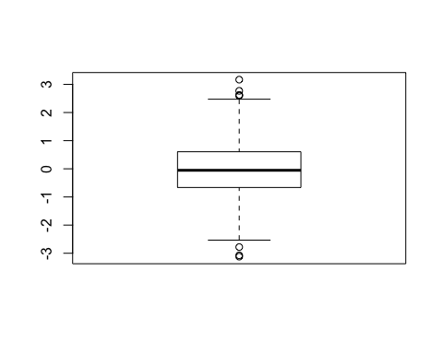

boxplot (x,horizontal = TRUE)

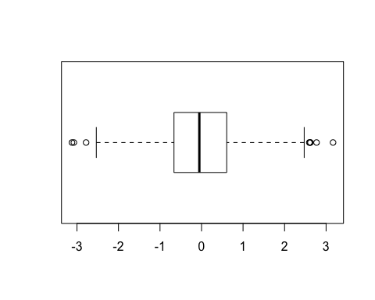

#hands on session 2  
#line plot  
read.table("bimm143_05_rstats/weight_chart.txt",header= TRUE)

## Age Weight  
## 1 0 3.6  
## 2 1 4.4  
## 3 2 5.2  
## 4 3 6.0  
## 5 4 6.6  
## 6 5 7.2  
## 7 6 7.8  
## 8 7 8.4  
## 9 8 8.8  
## 10 9 9.2

weight <- read.table("bimm143_05_rstats/weight_chart.txt",header= TRUE)  
plot(weight ,pch=15, cex=1.5, lwd=2, ylim=c(2,10), xlab="Age(months)", ylab="Weight (kg)", main="Baby Weight with Age")

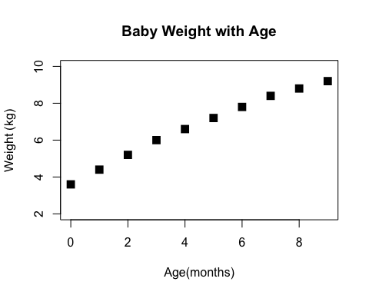

#View(weight)  
plot(weight[,1], weight[,2],typ="o")

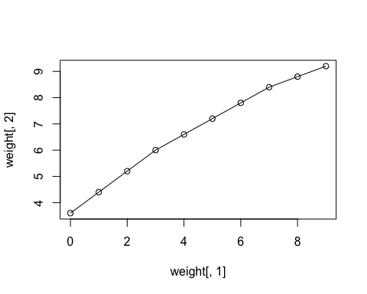

plot(weight$Age, weight$Weight, typ= "o",pch=15, cex=1.5, lwd=2, ylim=c(2,10), xlab="Age(months)", ylab="Weight (kg)", main="Baby Weight with Age",col=c("blue","red"))

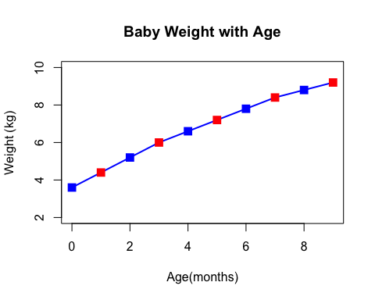

plot(weight$Age, weight$Weight, typ= "o",pch=15, cex=1:3, lwd=2, ylim=c(2,10), xlab="Age(months)", ylab="Weight (kg)", main="Baby Weight with Age",col=c("blue","red"))

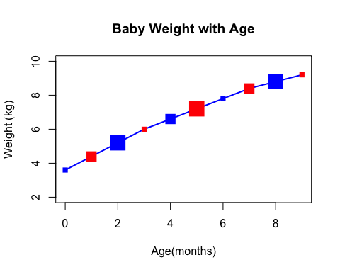

# barplot  
barplot(VADeaths, beside = TRUE)

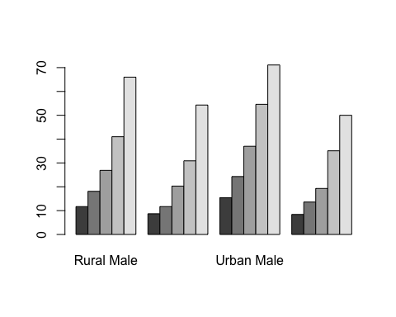

# Input our feature count data  
mouse <- read.table("bimm143_05_rstats/feature_counts.txt", header= TRUE, sep="\t")  
#View(feat)  
#?barplot  
barplot(mouse$Count, horiz= TRUE, names.arg= mouse$Feature, las=2)  
  
#change margin so we can see labels  
# default parameters  
par()$mar

## [1] 5.1 4.1 4.1 2.1

par(mar= c(5.1, 11.1, 4.1, 2.1))  
barplot(mouse$Count, horiz= TRUE, names.arg= mouse$Feature, las=2)

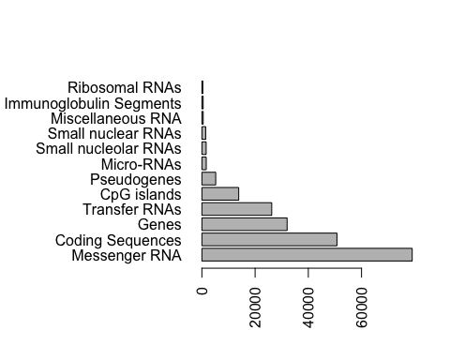

#colors  
barplot(mouse$Count, horiz= TRUE, names.arg= mouse$Feature, las=2, col=cm.colors(5))

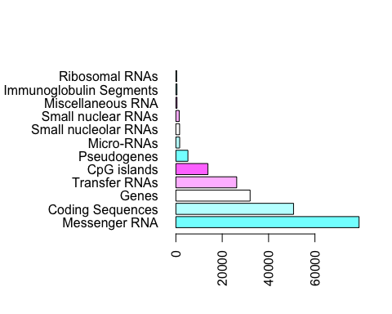

mf <- read.table("bimm143_05_rstats/male_female_counts.txt", header= TRUE, sep="\t")  
#View(mf)  
barplot(mf$Count, names.arg= mf$Sample, las=2, col= c("blue1","red2"))

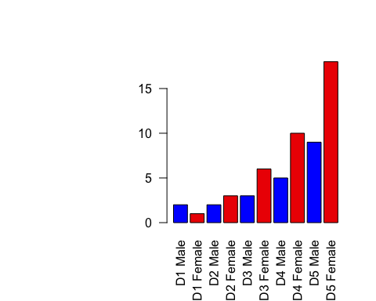

par(mar= c(3.1, 6.1, 4.1, 2.1))  
  
#expression data  
e <- read.table("bimm143_05_rstats/up_down_expression.txt", header= TRUE, sep="\t")  
#View(e)  
  
 #how many genes  
nrow(e)

## [1] 5196

#how many up, down and all around?  
table(e$State)

##   
## down unchanging up   
## 72 4997 127

plot(e$Condition1,e$Condition2, col=e$State)

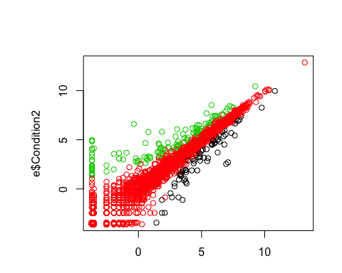

#palette  
palette(c("red","light gray","blue"))  
plot(e$Condition1,e$Condition2, col=e$State)

